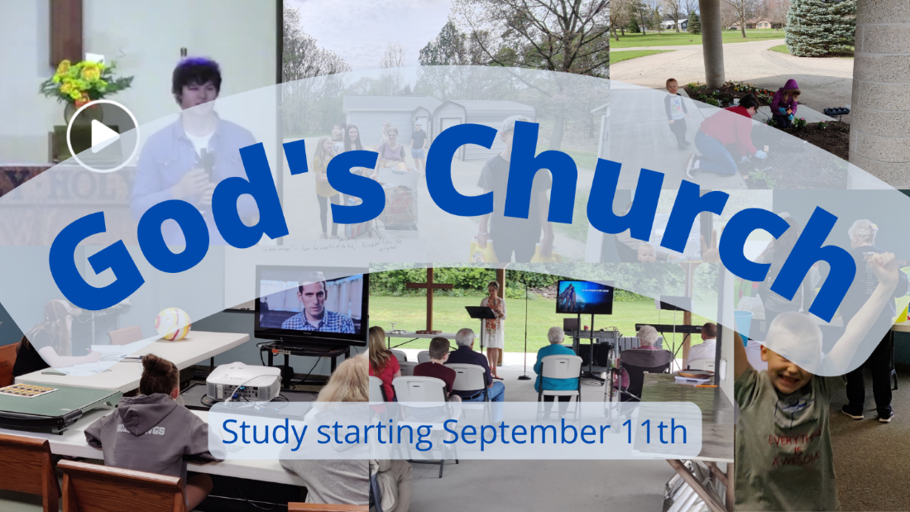

Church, Mission, and Ministry

  - Lesson 1: The Church is the body of Christ

Getting going
- Which of these examples or groups do you think the church is most like?
  - School - Children gathered in age-grouped classes. They had curriculum and teachers. They did learn, or at least that was our hope. We also had lots of classes for adults. And we did hope to educate people. In many ways, we were like a school.
  - Club - perhaps a social club or a service club. We have regular meetings. We have members and a process for joining. Members can become leaders in the church. We do lots of different things together, including service projects and social gatherings. At church, as in a club, we make friends and find a center for our socializing.
  - Store - Small churches are like neighborhood mini-marts; large churches are like department stores. Both churches and stores “sell” products. Both have professional staffs. Both “market” their wares in the community, hoping to attract interested “consumers.” Larger churches, like larger stores, offer a wide array of “products.” Smaller churches, like small stores, offer more personal service but fewer “products.” If the church you attend provides what you’re wanting to consume, you continue to go there. If that church stops meeting your needs, you think nothing of finding a better church, just as you might switch markets or clothing stores.
  - Hospital - When you’re physically sick, you go to a hospital to get well. Similarly, churches promise to help you overcome your spiritual ailments. Both hospitals and churches have professional experts to help you heal (doctors, pastors). Both hospitals and churches offer specialized treatments for particular ailments (in churches: singles groups, AA groups, etc.). Both hospitals and churches are staffed by people who care, or at least that’s the way it should be.
  - Political or social movement – People come together for a short time. The goal is not to make an institution or build anything, but usually to communicate a message and change the current system. There is an ideology that people buy into and slogans.

Which do you think the church is most like? Least like? Do you have other examples?

- I’m sure we’ve all used examples like these to illustrate the church to friends and neighbors at times. What is the danger of doing so (try to give specific examples)?

Getting into God’s Word
- Read Ephesians 1:19-23. It’s one of the best summaries of the Church. According to this passage, what is the church? Who or what is the head of that body?

- This idea that Jesus is the head of the body, which is the Church, is not an abstract idea for the Apostle Paul. Read also Ephesians 2:19-22. What else do we learn about the Church from these verses?

- Ephesians 4:1-6 provides some of the last answers about what the Church is. Read that section.

- In Ephesians 4, Paul says we have the “unity of the Spirit”. What do you think that means?

- Ephesians 4:5 tells us how everyone gets into the Church. We have “one Lord”. This is a reference to the idea of pledging to obey someone. The Ephesians did not call Caesar Lord, but Jesus Christ. We have “one faith”. We are part of the Church through the gift of faith and not our sacrifices. Lastly, we have “one baptism”. We participate in a specific physical act to get into the body of Christ.

- According to what we’ve learned in these verses, how is the Church similar to or different from any of the examples we gave in 1 above?
(club -

- What challenges or temptations might Paul have faced to define the church in different ways (as a social group, or political movement, etc)?

- True/False If someone reads the Bible on their own and believes (and let’s assume they actually believe), they are part of the Church.

- Look back at Ephesians 1:19-23. According to this verse, Jesus is not just the head of the church. The church is also “the fullness of him who fills everything in every way”. What amazing promise is captured in those few short words?

Going forward in faith
- This lesson wants us to hold on to two truths. First, that the Church of Jesus is a physical thing, made of people gathered by the means of grace (baptism). Second, that the Church is spiritual, connecting people across time and space through Jesus the head. Which do you think is easier to accept? Which is harder?

- What’s a passage from this Scripture that impacted you?

- How are you going to respond to this message?

- Who is one person you’d like to share this with?

