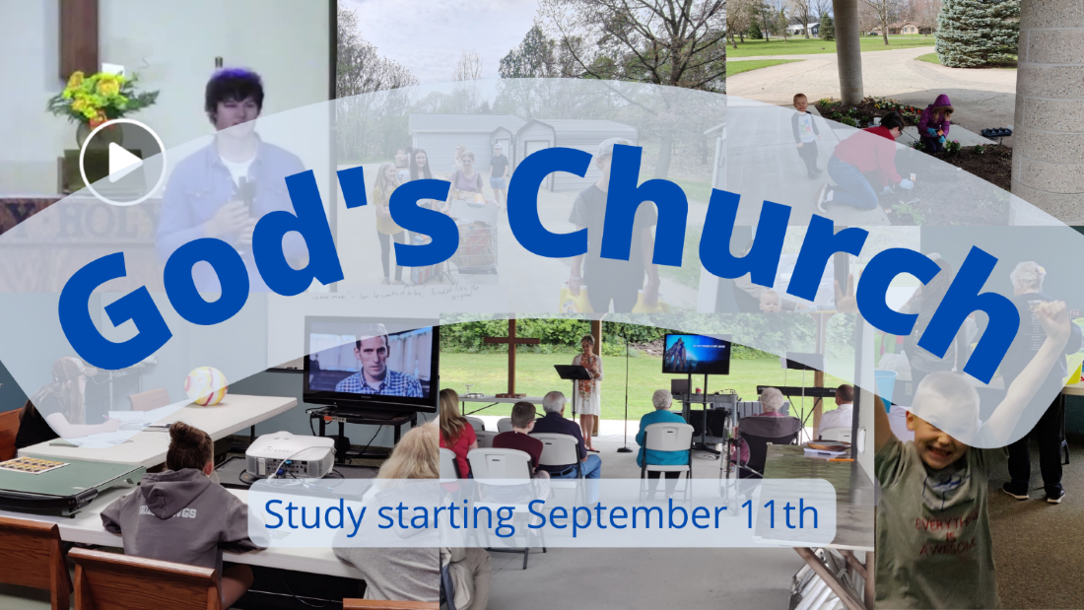

Church, Mission, and Ministry

  - Lesson 3: The Church is found and identified by its marks.

Getting going
- In the first lesson, we said that the Church is the body of Christ, “the sum total of God’s children” (CFW Walther, Church and Ministry, Thesis 1). While it shares many similarities to a school, hospital, political movement, or club, it is more than all of those things. Henry Barrow has a very picture-full description, saying,

“This holy army of saints is marshaled here [on] earth by these officers under the conduct of their glorious emperor Christ. It march[es] in this heavenly order … against all enemies both bodily and ghostly. [Within itself] it is as peaceful as Jerusalem, but it is terrible [unto its enemies] as an army with banners, triumphing over their tyranny with patience, their cruelty with meekness, and over death itself with dying. Thus through the blood of the spotless lamb and the word of their testimony, they are more than conquerors… through the power of the Word, they have power to cast down Satan like lightning, to tread upon serpents and scorpions, to cast down strongholds, and everything that exalt[s] itself against God.” (“A True Description of the Visible Church”, quoted in Mark Dever, The Church)

In the second lesson, we learned that the Church can be found and identified, despite all the division and differences, and the fact that true membership in the Church is invisible to us. A good Lutheran teacher Johannes Quenstedt wrote,

The multitude of people that constitute the church we do see, but whether those persons are the church, that we do not see; that is, the people that belong to the church we see and notice, but whether these persons are true and living members of the church, that is not manifest to us” (ibid.). (Quoted in CFW Walther, Church and Ministry, pg 47-48)

- How do you know where the Church (the people of God) actually is? How do you recognize it? For example, some people say, “Unity is the sign of recognition, the ‘calling card’ of the church,” he said.” (https://www.archbalt.org/holy-spirit-creates-unity-universality-of-church-pope-says/) They seem to say we identify the Church of God by unity. Other people say, ““Love indeed is the true sign of every true disciple of Jesus Christ.” (https://www.churchofjesuschrist.org/study/general-conference/2018/04/pure-love-the-true-sign-of-every-true-disciple-of-jesus-christ?lang=eng)
“Jesus was by no means suggesting that faithfulness to his word, the sacraments or to a disciplined approach to church life did not matter. Rather, that the one quality that must suffuse all three (and indeed church life generally) is love” The Indispensible Mark of the Church | Place for Truth - Alliance of Confessing Evangelicals (alliancenet.org)
Is it true that we find the Church where there is unity? If there isn't unity, is God at work? Last time we saw that the Bible teaches the Church can be found despite differences and divisions. Let’s find out today how to find the Church.

Getting into God’s Word

- The church in Corinth was not united. In 1 Corinthians 3:3-4, “3 You are still worldly. For since there is jealousy and quarreling among you, are you not worldly? Are you not acting like mere humans? 4 For when one says, “I follow Paul,” and another, “I follow Apollos,” are you not mere human beings?” Paul handles this disunity in many ways. He tells them to expel the immoral Christian. He tells them to handle their disagreements outside of the courts. He reminds them that marriage should last. He encourages them to enjoy the real connection with God instead of meals for idols. He deals with issue after issue – even worship practice! Some people wanted to speak in tongues, others wanted to prophesy. Read 1 Corinthians 14:1-5, especially verse 5.

Which did Paul prefer – tongues or prophecy?

And why?

What would prophecy do?

What does it mean, “to edify?”

- Paul picks prophesy, the preached and declared Word of God, over anything else. The Word builds the Church. In fact, he will go on and say, if someone is prophesying and an unbeliever comes in, they will say, “God is really among you.”

Paul is not saying unity is bad. No way! But what is Paul saying?

- The Bible says something similar in many other places. Read Matthew 28:18-20, 1 Peter 1:23, Galatians 1:8-9, 2 Timothy 4:1-5. Taken together, what do these passages teach us about the Word of God?

- From these passages, we learn not only that the Word of God, and particularly the gospel, is God’s loving word of grace. It is also the way we can identify God’s people. We call it the “mark of the Church”, along with the gospel in the Sacraments. What does it mean to say that the Word of God, the gospel in Word and Sacraments, is the mark of the Church?

- You go into a church. There are lessons from the Bible, prayers to a saint, and the sacrifice of the mass. As best as we can tell, is the true Church present? Are believers there?

- You walk into another gathering of people. There are lessons from the Bible and the Book of Mormon. Is the true Church there, as best as we can tell?

- It’s not unusual though to hear other marks of the Church. For example, Michael Bird writes, “Those four adjectives - one, holy, catholic, and apostolic - have traditionally been known as the marks of the church by which you can know that you have the true church.” (Michael Bird, What Christians Ought to Believe, pg 197)

Where do these four marks (one, holy, catholic, apostolic) come from? What is their source?

What do these marks mean? What does “one” mean as a mark of the Church? What does “holy” mean as a mark of the Church? What does “catholic” mean? What does “apostolic” mean?

What is the difference between saying the Word of God and particularly the gospel is the mark of the Church, and saying “one, holy, catholic, and apostolic” is the mark of the Church?

- “The church will endure because the Word of God will endure (1 Peter 1:23-25). We have God’s promise that when the Word is proclaimed, he is at work to accomplish his purposes (Isaiah 55:10,11). That is why the church gathers around the Word and sacraments and uses the Word and sacraments. Jesus promised his presence when believers gather in his name (Matthew 18:20). The Spirit is at work through the gospel of Jesus, bringing unbelievers to faith and strengthening the faith of believers (Romans 10:17; 2 Thessalonians 2:13,14; John 3:5,6; Titus 3:5).” (https://forwardinchrist.net/truly-lutheran-church-believers/) (The difference between someone who is claimed by the lord and someone who has a passport saying they belong)

Going forward in faith
- Story from Gloria O - Don’t lose the simplicity of this lesson. The Gospel in Word and Sacraments are the distinguishing identifiers of God’s Church. Don’t minimize your role in making the gospel clear. How can we help make these strong and clear in our churches so that they are seen as the Church?

- What’s a passage from this Scripture that impacted you?

- How are you going to respond to this message?

- Who is one person you’d like to share this with?

Next lesson what is the mission or the work of the Church.

