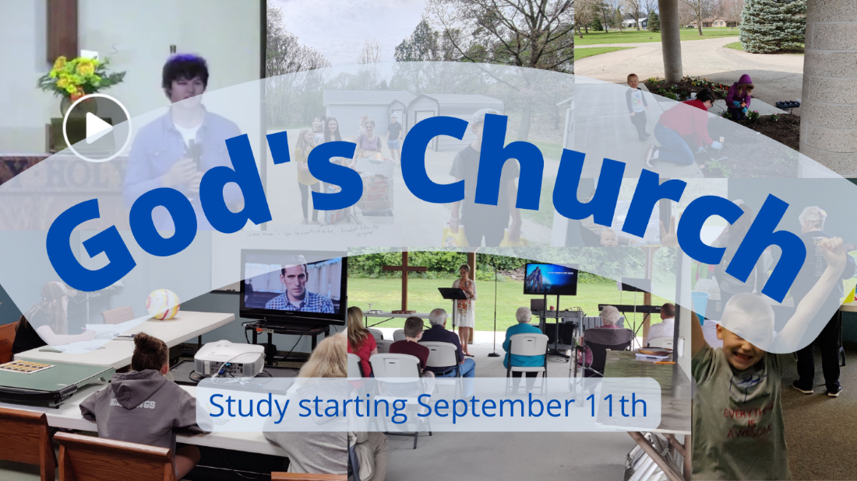

Church, Mission, and Ministry

  - Lesson 7: Mission becomes ministry

Getting going
- Landon is a pastor in rural Iowa. Pastoring a small church was difficult from the start. Between the time he was called and his first day, a dozen people left the church. Another dozen left after the first couple of Sundays. There were only about four dozen left. Landon admitted, “I was so discoursed, I wasn’t sure I would make it.” But he said, “I started working one-on-one, bringing people into the church myself.” The personal revival in his own soul gradually spread to the congregation. It took almost five years, but noticeable changes began to occur. Average attendance moved above one hundred for the first time in decades. They renovated and campus and added a pastor. The children’s ministry began to thrive. What made the difference? “It’s not about how tough or brave you are. It’s about endurance. You take your licks and keep going.”

Landon and his church are a good example of a church that really learned to take God’s mission to heart and put it into practice. What factors do you think made a big difference?

- In the first lessons, we considered who the Church is. In lessons 4-7, we are considering the mission God gives to his Church.
- Lesson 4 surveys the variety of ways groups of people think about the mission God has given to them.
- Lesson 5 surveys the larger mission of God and considers the work of God’s people in light of his work
- Lesson 6 clarifies the Church’s mission among God’s many commands
- Lesson 7 lets us see how mission becomes ministry
- Lesson 8 – “who does what?”

Getting into God’s Word

- The early Church kept the focus on the mission and that led to ministry. Acts 6:1-8 is a great example. Please read those verses. According to this section (note verses 1 & 2), what two duties or tasks did the believers in Jerusalem do?

Who gave them these duties (may not be written write in this section)?

What did they focus on the most and how did the make that happen?

Are there any hints in the text to how they felt about the tasks and the fact they had to different jobs to do?

According to verses 7 & 8, how were the first Christians blessed as they focused on their mission?

- Another place to see the balance of mission and ministry is the Apostle Paul’s instructions to Timothy. In 1 Timothy 1:3-7, the apostle Paul gives Timothy his mission. He repeats it in 1 Timothy 6:11-14. Look at those verses and summarize again the mission Paul gave to Timothy.

After that general mission statement, Paul gives lots of other instructions. Skim through 1 Timothy 2-5. What are some of the many other instructions Paul gave Timothy?

What reaction do you have to all the tasks Paul gave Timothy?

- Describe the connection between the mission Paul gave Timothy and the many tasks. Are they connected? Are some of the tasks just random, unconnected to the overall mission?

- What are some ways that Paul helped Timothy distinguish between mission and ministry?

- Agree or disagree. For a local congregation to be faithful to God’s mission, it needs to do as comprehensive ministry as possible, no matter how many resources it has available. Like the first Christians, we need to both carry out the ministry of Word and prayer as well as care for the widows. Like Timothy, we have to do so many tasks. Do you agree or disagree?

As an example, consider what Pastor Tim Keller says. “Every church must seek to be true to all of the rich images in Scripture. Yet no church has a perfectly balanced set of gifts and strengths; nor does it have excess leadership or financial capacity! What does it mean, practically, to be faithful to these limitations yet true to all the biblical metaphors? It means a church should strive to supplement its strong ministries by seeking to do all the forms of ministry as skillfully as possible in an integrative way. It should recognize and capitalize on its strengths but never give up seeking to shore up its weak areas, out of respect for all the things that Scripture says a church is and does. It is not unlike the relationship of individual spiritual gifts to Christian duties. For example, the Bible tells all Christians to evangelize and love their poor neighbor. Yet some people have gifts of evangelism and others gifts of mercy and service. So Christian individuals should find ample opportunities to use their gifts but must still take care to do what the Bible says are their duties, even those they do not feel they are very good at.” (Tim Keller, Center Church, pg 293)

- Enjoy this encouragement to put mission into ministry from Mark Dever. “Many Protestants have begun to think that because the church is not essential to the gospel, it is not important to the gospel. This is an unbiblical, false and dangerous conclusion. Our churches are the proof of the gospel. In the gathering of the church, the Christian Scriptures are read. In the [sacraments] of the church, the work of Christ is depicted. In the life of the church, the character of God himself should be evident. A church seriously compromised in character would seem to make the gospel itself irrelevant. The doctrine of the church is important because it is tied to the good news itself. The church is to be the appearance of the gospel. It is what the gospel looks like when played out in people’s lives. …Christians, not just as individuals but as God’s people together in churches, are the clearest picture the world sees of who God is and what his will is for them.” (Mark Dever, The Church, pg 165)

Going forward in faith
- A couple of years ago we went through a Bible study that helped us assess our mission and ministry. We produced a task list with 84 items that a church in Otsego-Plainwell should do to do good ministry. Skim through the list. Is ministry easier, harder, or just as complicated as 2,000 years ago?

- Does being part of the congregation at Peace motivate you to do ministry?

- What’s a passage from this Scripture that impacted you?

- How are you going to respond to this message?

- Who is one person you’d like to share this with?

